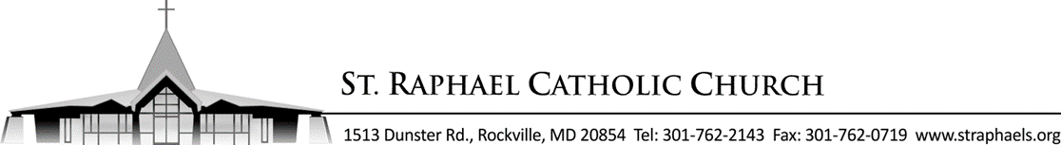

Sponsor Eligibility Form
I, ______________________________________________, have been asked to be a sponsor/witness of
(Sponsor’s First Name, Last Name – please print)
___________________________________________ for the Sacrament of Baptism/Confirmation/Wedding.
(Confirmation/Baptism/Wedding candidate’s name – please print)
Relationship of Sponsor to candidate: __________________________________
Sponsor’s Phone number: ( __ ) __ __ -______________
I further state that: YES NO
- I am at least 16 years old.
- I am a registered member of _______________________________ Parish.
- I have received the sacraments of initiation (Baptism, Confirmation, Eucharist).
- I participate weekly in Sunday Mass.
- I give witness to my faith in Jesus Christ by receiving Him in Holy Communion
regularly.
- If married, my marriage is valid and blessed by the Catholic Church OR
If single, I affirm that I am not in a cohabiting relationship (living together
without marriage in the Catholic Church).
- I promise to pray and to be a good example for my confirmation candidate.

Sponsor’s Signature: ______________________________________________
To be completed by the sponsor’s parish:
I,______________________________________, hereby testify that the above person is a registered
Name of priest or deacon (printed)
member of our parish and affirm that he/she fulfills all the requirements to be a sponsor / godparent.
______________________________________________ ____/____/________ Parish Seal
Priest’s / Deacon’s Signature Date

St. Raphael Catholic Church, 1513 Dunster Road / Rockville, MD 20854

